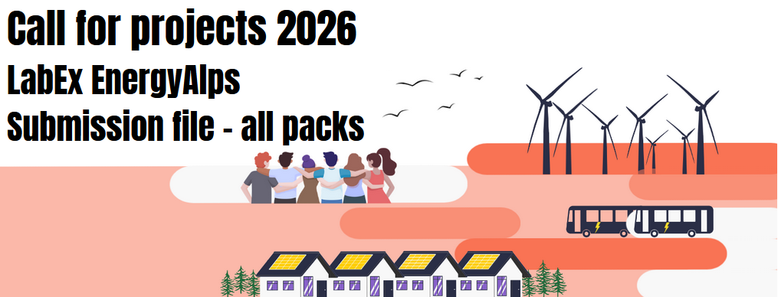

Project acronym
Project title
Relevant work packages
Project coordinator (name, surname, research unit/team, email)
Co-leader (same information)
Call pack | ☐ Seeding funding  ☐ PhD grants  ☐ Post-doc grants

Project description
(all packs: max 4 pages)
- Scientific and/or technological background, project objectives, and positioning with respect to the state of the art.
- Scientific program, methodology, expected results, and potential impact.
- Project organization: strategy, resources mobilized and their availability, schedule, feasibility, and use of funds.
- Consortium: synergies, complementarities, and partners’ roles.

List of references
(all packs: max 1 page)

CV of the project coordinator
(all packs: max 2 pages)
CV of the project coordinator specifying ongoing projects and available resources on LabEx themes. Highlight the resources relevant to the achievement of the project.
To specify, in addition to any other information provided by the project leader:
Involvement in other ongoing projects and their end dates
Current supervision rate (for PhD or post-doc calls)

List of permanent staff involved in the project
(all packs)
NAME Surname | Position/ employer | Research unit | Full time equivalent over the project | % supervision of the thesis, if applicable

Request for funding in euros
(all packs)
Operation / Equipment/ Internships (all packs)
Operations/ Equipment | Amount (euros) | Short description
Internship (€700/month)
Equipment
Traveling costs
External services
Communication actions
Other expenses

Specific elements
PhD Thesis (PhD Thesis pack)
Intended doctoral school:
Thesis supervision:
Quality | NAME Surname | HDR holder (yes/no) | Laboratory
Thesis director (HDR holder)
Co-director (if applicable)

If a posibility of co-funding the doctoral grant is applicable, specify the funding source and whether it is secured.

Role of the recruited PhD candidate (max 1 page):

Postdoc (postdoc pack)
Requested duration (in months):
Role of the recruited post-doc (max 1 page):

Project submission statement
(all packs)
To be signed by the director of the project coordinator’s research unit. In case of multiple submissions by the same research unit, ranking by the research unit’s direction is not mandatory.

I, the undersigned, (first name, last name),
Director of the research unit (acronym and full name),
certify that I have taken note of the submission of the above-mentioned proposal within the framework of the “EnergyAlps” call for projects.


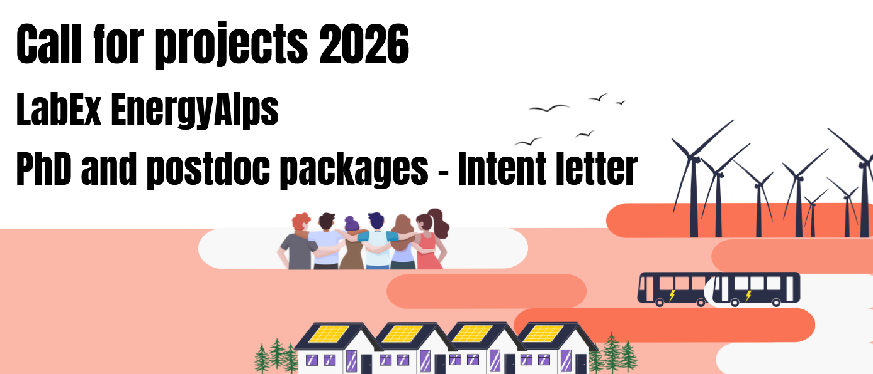

Optional, to be sent before November 10, 2025

Project acronym | optional
Project title | indicative
Project coordinateor (name, surname, position, employer, research unit/team, email)
Co-leader (same information)

Project description
(max 2 pages)
Any element allowing the LabEx office to assess the project’s intention and possible support modalities.

